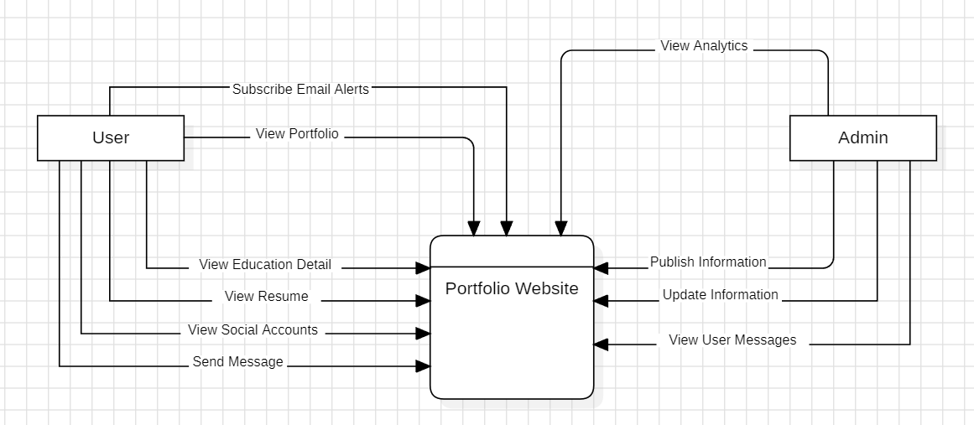

Fig: Data Flow Diagram of Personal Portfolio Website